Q’in Dynasty
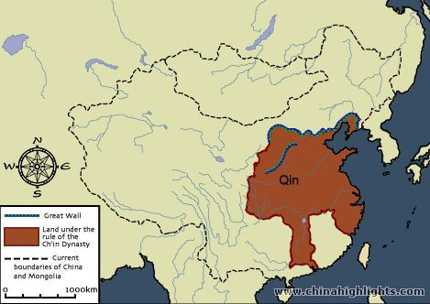
秦朝
Years: 221-207 BC (14 years)
Founder: Q’in Shi Huang
Religions: Ancestor Worship, Legalism
Q’in
Capital City: Xianyang

Inventions
-A large, mostly dirt wall that later would become The Great Wall
-A massive road system
Achievements
-Created a single written language to be used throughout the country
-Created a single set of laws to be used throughout the country
-Brought the people of China together as one people
-Greatly improved trade by creating a money system
-Greatly improved the military with new tactics and equipment
Other Information
-The modern name of the country, “China” comes from this original dynasty.
-They built a huge tomb for their first emperor that is guarded by hundreds of life-sized clay statues that still stand today.
-Harshly punished anyone who disagreed with the emperor. 400 people were buried alive for questioning the emperor and even his own son was banished from the empire.

Han Dynasty
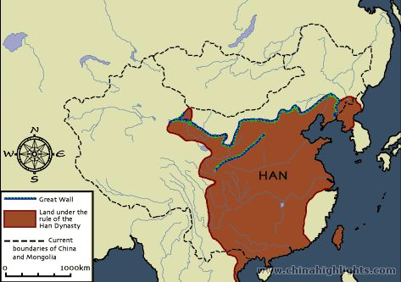
漢朝
Years: 206 BC – 221 AD (427 years)
Founder: Liu Bang
Religions: Ancestor Worship, Confucianism, Taoism
Han
Capital City: Chang’an

Inventions
-Wheelbarrow
-paper
-Seismograph (Earthquake Detector)
-Water Wheels which powered many mechanical tools such as a clock
-Ship rudder
Achievements
-Opened the Silk Road connecting Europe and Asia for the first time.
-Used negatives numbers in math for the first time in history.
-Grew to 50 million people

Other Information
-Women had legal rights, though not as many as men
-Forced everyone to follow Confucianism so they’d support the government

Tang Dynasty
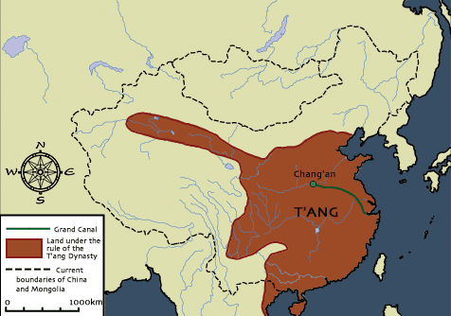
唐
Years: 618-906 AD (288 years)
Founder: Li family
Religions: Ancestor Worship, Confucianism, Taoism, Buddhism
Capital City: Chang’an
Tang

Inventions
-Woodblock printing
-Playing cards
-Toilet paper
Achievements
-Implemented civil service exams to test people who wanted to work for the government.
-Greatly improved farming with new techniques like irrigation ditches
-Managed a 20,000 mile long postal network
-Focused on literature with nearly 50,000 poems being written that still exist today.
Other Information
-Saw huge growth in Buddhism
-Welcomed foreign cultures via the Silk Road leading to growth in art, music and fashion.
-Considered the “golden age” of Chinese civilization

Song Dynasty
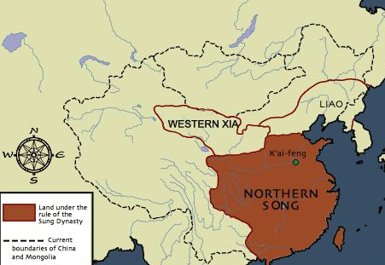
宋
Years: 960 – 1279 AD (319 years)
Founder: Taizu
Religion: Buddhism, Confucianism, Taoism
Capital City: Bianjing
Song

Inventions
-gun powder
-paper money
-movable type printing
Achievements
-Oversaw a great growth in literature and knowledge due to the use of movable type
-First Chinese government to create a permanent navy
-Greatly increased the use of civil service exams to improve the quality of government officials
-Created incredibly lifelike sculptures out of wood
-Increased quality and variety of ceramics
Other Information
-population doubled in size due to advances in farming techniques
-created public schools to improve education
-created retirement homes for elderly lower classes who could no longer work

Yuan Dynasty
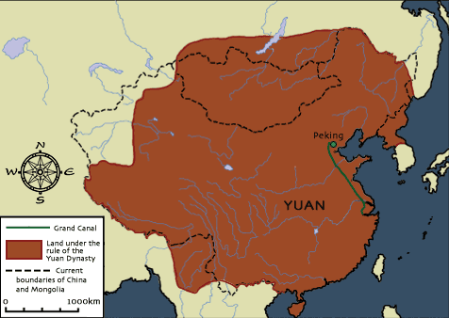
大元
Years: 1279-1368 (89 years)
Founder: Kublai Kahn
Yuan
Religions: Ancestor Worship, Confucianism, Taoism, Buddhism
Capital City: Dadu

Inventions
-hand cannon
-teapot
-land mine
-Though they invented few new things they greatly improved many existing inventions such as guns and movable-type printing.
Achievements
-Re-opened the Silk Road increasing trade with the west.
-Greatly improved farming by extending the Grand Canal.
Other Information
-Only dynasty ruled by non-Chinese
-Built many hospitals and orphanages to help the poor.
-Visited by Marco Polo from Italy
-Invited Christian missionaries to come and teach the people about Jesus.
-Encouraged contact with Europe bringing in many new foods and ideas.

Ming Dynasty
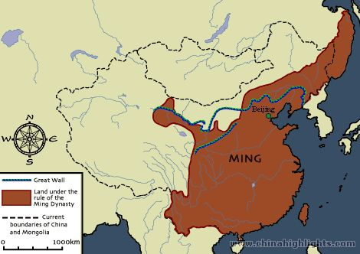
大明
Years: 1368-1644 AD (276 years)
Founder: Zhu Yuanzhang
Religions: Taoism, Confucianism, Buddhism, Islam
Ming
Capital City: Nanjing

Inventions:
-Toothbrush
-“Nest of Bees” arrow launcher
-“Fire Dragon Issuing from the Water” rocket launcher
Achievements:
-Population grew from 65 million to 160 million.
-Built the Forbidden City, a massive palace for the emperor.
-Completed the Great Wall adding hundreds of guard towers and filling in the remaining gaps.
-Sent explorers around the world sailing around Africa and possibly even reaching North America.
-created amazing porcelain art like vases and statues
0ther Information:
-Some historians say it was the most advanced nation on Earth at the time
-Returned to the old Tang and Song styles of sculpture and painting without adding much new technique.
-Cut off most contact with foreign nations, returned to isolationism

Ming Dynasty
Unity/Power/Size: _____

Technology: _____

Art/Architecture: _____

Overall: _____

Yuan Dynasty
Unity/Power/Size: _____

Technology: _____

Art/Architecture: _____

Overall: _____

After completing your report cards answer the questions below.
- Which dynasty received the highest technology grade? Why? (If you had a tie pick the one you think is better overall.)

- Which dynasty lasted the longest? Why do you think it was able to do so?

- Which dynasty received the highest overall grade? Why? (If you had a tie pick the one you think is better overall.)

- If you had to choose to live in China during one of these dynasties which would you choose to live in? Why?
Heaven’s Report Cards
The main goals of a government are to unify and protect its people, grow its size and population, improve technology and increase artistic achievement. Rate each of the Chinese dynasties based on how well (or poorly) they did these things. For each category give a grade A through F (or NG for No Grade) and a short reason why you are giving that grade. The 1st is completed for you – be sure to review it.
Q’in Dynasty
Unity/Power/Size: __B+__
They unified writing and laws but they made people so angry that they fought back against them so they only lasted a short time.
Technology: __B-_
Began building The Great Wall and built a road system.
Art/Architecture: __C__
Built statues but not really for artistic reasons.
Overall: __B-_
They unified the people but didn’t last long and didn’t really invent that much. Plus, they were violent and quite hated by many.
Han Dynasty
Unity/Power/Size: _____

Technology: _____

Art/Architecture: _____

Overall: _____

Tang Dynasty
Unity/Power/Size: _____

Technology: _____

Art/Architecture: _____

Overall: _____

Song Dynasty
Unity/Power/Size: _____

Technology: _____

Art/Architecture: _____

Overall: _____

